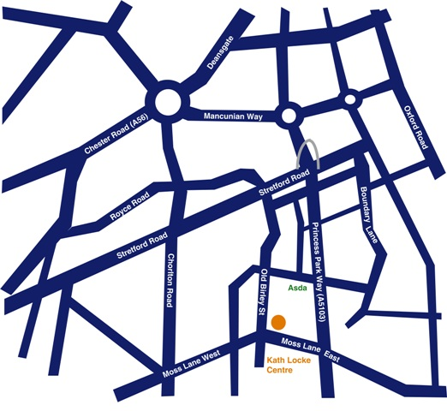
Location
Moss Lane East is off Princess Parkway. The Kath Locke Centre is on Moss Lane East and near the junction of Moss Lane East/ Moss Lane West and Alexandra Road/ Old Birley Street.
Buses
Bus number 15 stops on Moss Lane East, bus number 85 stops at the first bus stop on Alexandra Rd and bus number 86 stops at the first stop on Moss Lane West.

