Visit to the Central Library, 5th March 2014
Comments from MDPAG

- Introduction
  - These observations arose from a short visit undertaken by members of MDPAG, as part of a wider group visit, and should not be considered a report of or the result of a full access audit. However, a number of serious access barriers were noted in the visit and are based upon consideration of barriers for disabled people with a range of impairments, and are also based upon local, national and best practice standards, including Manchester’s own design standards, Design for Access 2 and BS8300. Our members include an experienced and qualified architect and town planner and a number of access auditors. We also note that under the Equality Act, Manchester City Council is required to anticipate the requirements of disabled people and to remove or to make reasonable adjustments to identified access barriers.

  - MDPAG were disappointed to find that because consultations were not undertaken with MDPAG before designs were finalised and products purchased, many of the barriers could have been avoided. We recognise that in order to remove the barriers and make reasonable adjustments, further costs will need to be incurred.

  - These comments are a brief outline of some of the barriers considered during a short visit and requested by Manchester City Council at very short notice. Fuller descriptions and explanations and further identification of access issues could be made available to Manchester City Council.

  - We look forward to seeing our comments reflected within the final report and receiving feedback on how improvements will be made to address the health and safety and access barriers required under the Equality Act.

1.4 The following key issues identified as requiring attention include elements in the following categories:

- Entrance

  - Although the entrance was still unfinished and needed signage to assist visitors, colours were mainly monotone, whites and greys, silver, glass and gold other than the main columns. Lack of colour contrast made it difficult to identify routes, which was replicated throughout the building. It would make it difficult not only for visually impaired people but also for other people who need elements for orientation.
  - Steps in the entrance hall were unfinished, the handrails were insufficiently contrasted with their background and were not turned down at the ends (c.f. Design for Access 2).
  - Further steps down to the basement, as visitors approached the entrances ahead and to the left and right were not highlighted in any way, had no visual contrast or tactile contrast and could be easily confused as a level surface. (see images 1 & 2).

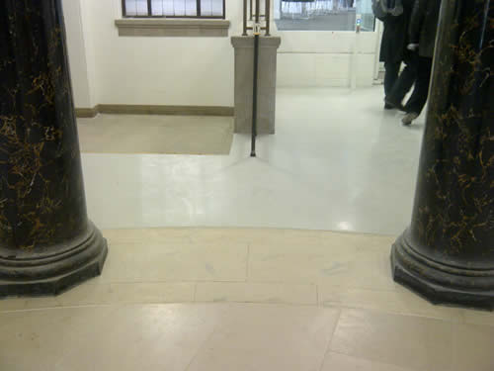

Image 1

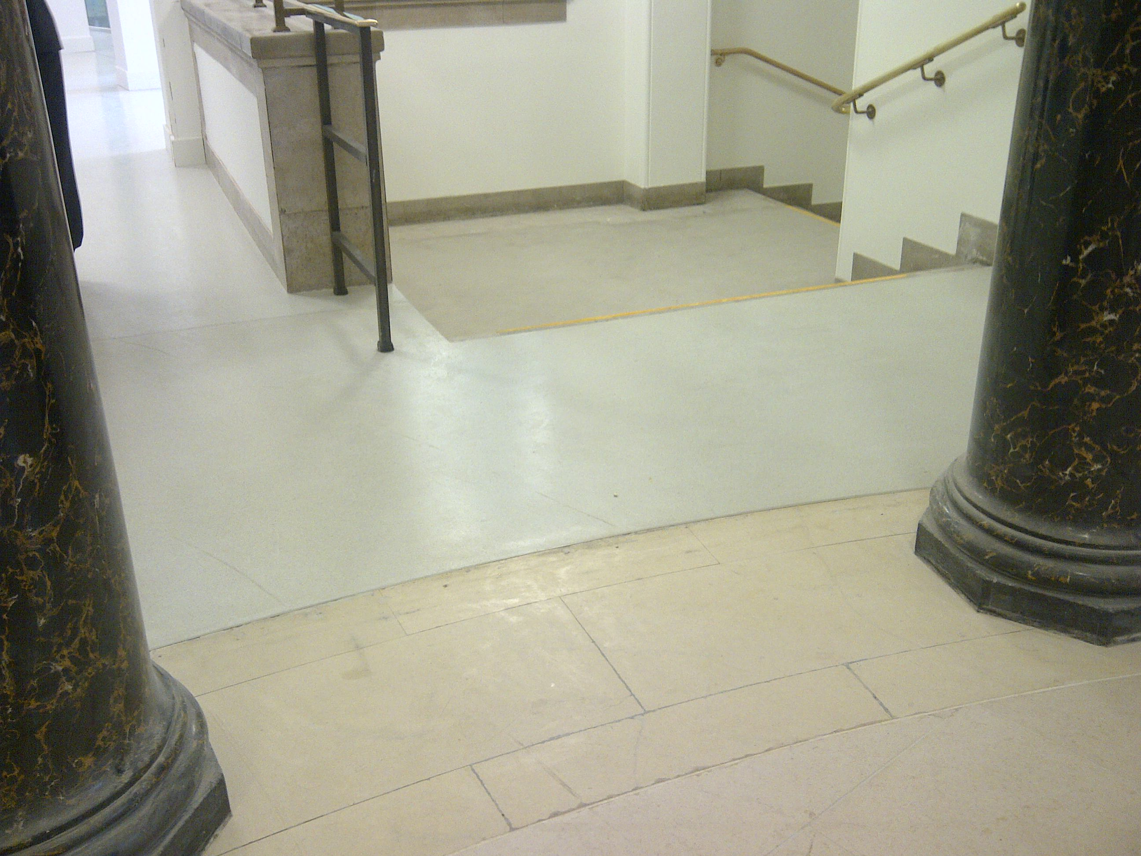

Image 2

- Surfaces

  - Floor surfaces, as shown in images 1 and 2 are also reflective and some staff we spoke with were concerned about people slipping, particularly in wet weather.
  - The surface of carpeted areas around the library was found to be very difficult and heavy to navigate by manual wheelchair users. It would have been helpful to have tested these in advance as carried out by MDPAG in other projects.
  - It was noted that staff behind the counters in the Reading Room would be standing on what appeared to be a clear glass ceiling. This could be very disorientating and worrying for some people.

4. Navigation and signage

4.1 Signage was very poor and made navigation around the building difficult. Signs outside lifts on some floors could not be seen on exiting from the lift and were located behind pillars, which was easier for people on the corridors. These pillars were extra obstacles for people to navigate around when exiting from the lift.
4.2 There were no signs on exiting from other key areas such as the Reading Room, to assist visitors in orientation or directions to other areas including lifts and toilets.
4.3 The content of signs was not helpful and in particular not clear on where the toilets and lifts were located, including the accessible toilets. (see image 3)

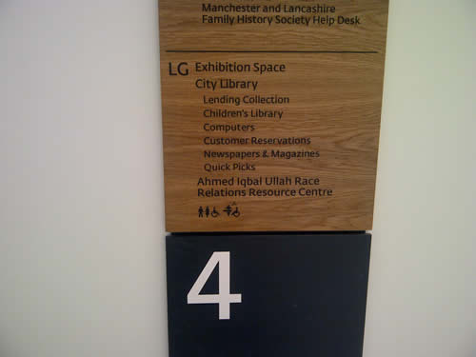

Image 3

4.4 Signage above meeting rooms were white lettering on white backgrounds and extremely difficult to read. (See image 4)

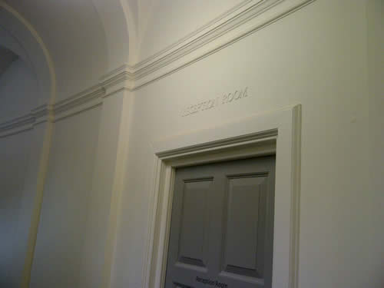

Image 4

4.5 Instructions to some facilities were not clear, particularly the advice on using the NW Film Archive, which uses capital letters throughout, making each letter difficult to distinguish and insufficient colour contrast. Manchester’s print design guidelines not the Clear Print Guidelines were not followed (see image 5)

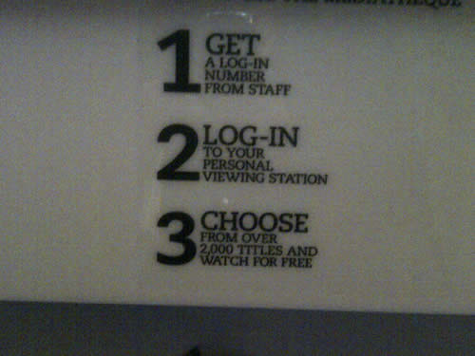

Image 5

4.6 The use of whites and greys within the library made it difficult to distinguish the different areas within the library on each floor.

4.7 The design of the ramp on the ground floor, which was very long and winding, made it much more difficult for wheelchair users to find the different elements within the area.

4.8 The whole area on the ground floor was confusing for visitors and made it difficult to orientate yourself within the library, although it is recognised that parts were unfinished. Signage was not helpful and there were no colours to identify separate areas. One member found that areas were very dark and poorly lit and when asking a member of staff for information and noting this, was told that visitors could always ask for assistance. However, MDPAG believes that the design of buildings for disabled people should allow for independent access for features.

- Obstacles

5.1 Visually impaired people found a number of obstacles within the library, as routes within the various sections were poorly identified.
5.2 Visually impaired people often orientate themselves by using walls and bins were located in a route on the ground floor and near to doors. (see image 6)

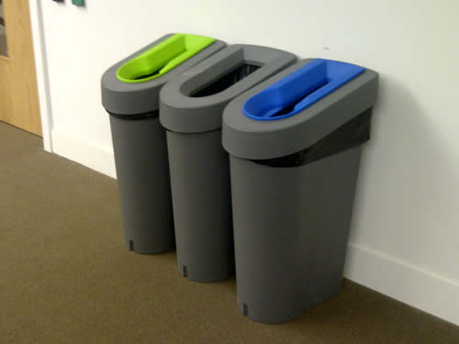

Image 6

  - Other obstacles encountered included white columns on the basement floor which were not highlighted in any way and various screens on different floors which were used inconsistently making it difficult for visually impaired people to learn where the accessible routes were.

- Steps and handrails

6.1 All steps had silver or gold/metal handrails set against a glass barrier which made it very difficult to distinguish them, because of a lack of contrast of colour and luminance. The use of lights to identify some but not all of the handrails is not a helpful option for energy conservation and will require constant maintenance. These lights also make the handrails both very warm where the lights are installed and cold where there are no lights and do not always make the handrails distinguishable as there are gaps between the lights. The lights also create glare and reflections which can be confusing to people with some visual impairments. Lack of colour contrast on surfaces also make the area very confusing. (See images 7 and 8)

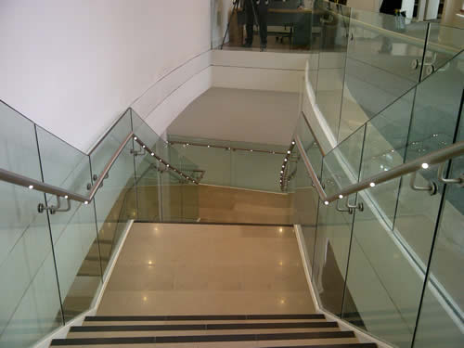

Image 7

6.2 Handrails are not turned down at the end creating a potential hazard for some people who could get their sleeves caught in the handrail. (cf. Design for Access 2)

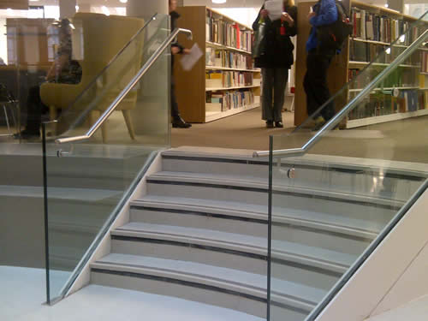

Image 8

6.3 Steps near the entrance, although not finished, currently are highlighted only in the centre and not near to the handrails, which could be confusing. (see image 9)

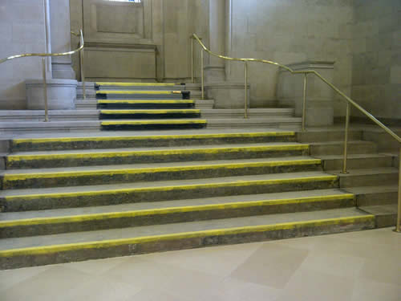

Image 9

7. Toilets

7.1 There was only time to view a small number of accessible toilets. The entrance was generally only accessible via the use of a Radar Key which makes it extremely problematic for disabled users who don’t have Radar keys. There was no information where to find a Radar key and after being told by a member of staff on another floor that staff at information points all had a key, staff on the ground floor information point near to archive section had no idea what or where the Radar key was available from.

7.2 The space within the toilet was generally good but the emergency cord was set too near the toilet and obstructed access to the toilet. (see image 10)

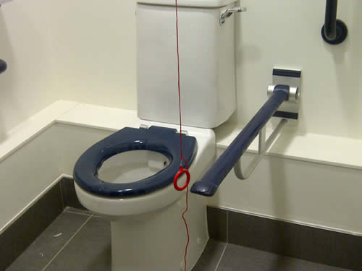

Image 10

7.3 Two hooks were also identified in one toilet which were not sufficiently colour contrasted with their surroundings and could be a hazard for some users. (see image 11)

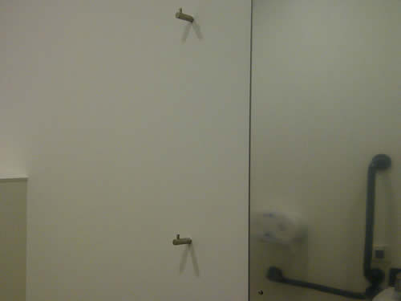

Image 11

7.4 Directions to other toilets for men and women were not easy to find and should have been available near to the accessible toilets as well as near to all main entrances and exits and from lifts.

8. Furniture and doors

8.1 Disabled people, older people who may not identify as disabled and other people need a range of seating. Design for Access 2 and other standards identify, as essential, seating with armrests and backrests and seating of different types and heights are also required.
8.2 The seating was very inconsistent throughout the library area with a large number of seats provided without backrests or armrests and with a very narrow seating area. Some seats were badly designed where the armrests were so low that users had difficulty using them. In areas where seating was provided there was no consistency in providing at least the standard seats required. (see image 14)
8.3 The seating was often located on carpeted areas but designed as grey seats on grey carpets, providing no colour contrast for users. (see images 12 & 13)

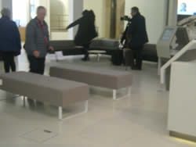 | 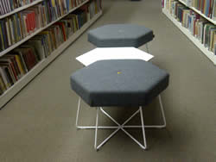

Image 12 Image 13

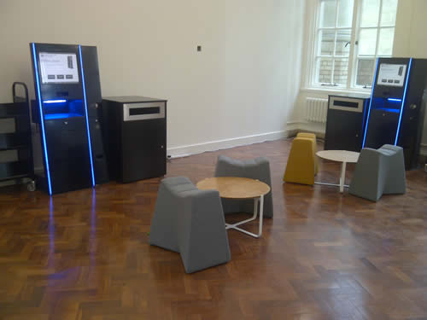

Image 14

8.14 Some visually impaired people found that the height of low tables located in access routes were another hazard, as they knocked into them or fell over them.
8.15 Some doors, including those to and from the Reading Room were very heavy and would be an obstacle for many people.

9. Digital, computer and information systems

9.1 Many of the information and other digital screens were too high and at an awkward angle for wheelchair users to use.
9.2 There was no information available on where the computers with text browsers and magnifying software was located and staff were unaware of where to find these computers or how to adjust the existing computers. Some adjustments could be made through the use of Windows accessibility features but there was no support or information for users or for staff.
9.3 Digital information screens were also not accessible and there were no options to make the screen size or the font larger or where there were, they were limited. Where input from a keyboard was required, there were no instructions or help available to make it work effectively.
9.4 Terms and conditions when logging on to computers, for example, were very difficult to read, and it did not seem possible to increase the size of the font at this stage.
9.5 General log on screens on the machines available to manage library accounts were also difficult to use independently and not easy to use intuitively. There was no easily available advice or help.
9.6 Some audio information may be considered particularly where the machines were located in areas not used for study and quiet reading.
9.7 It would have been helpful for these digital devices and their software to have been user tested with disabled and other people as advised by all recognised digital information advisers who deal with accessibility and useability, including MDPAG.
9.8 MDPAG were unable to review and assess all of the digital equipment available on the visit and there are other facilities, such as the storage stacks which we noted were difficult to use. We were unable to access any of the study carrols to assess how accessible the facilities were for disabled people.

10. Sound and acoustics

10.1 It was difficult to assess the general sound levels in each department because of the nature of the visit and the general building and refurbishment work still ongoing. However, a major issue was clear in the Reading Room where the original echo seems to have become even more apparent. This was an issue raised with the architect and developers by MDPAG in the very early stages of the plans and we were assured that it would be possible to consider materials to reduce the impact of the echo. However, this has not been carried out successfully.

11. General comments

11.1 The austere nature of the design and lack of colour and colour contrast resulted in a difficult environment to navigate and enjoy for many disabled people. Although it is recognised that it is not finished, it did not appear a welcoming environment for disabled people as there were so many access barriers, obstacles and hazards. It was also noted that some inclusive design features appeared not to have been integrated in the design from the beginning making adjustments more expensive and difficult. There are likely to be other issues that will become apparent once the use of the space and the way procedures operate are observed. Some features, such as the café and all the facilities in the basement and under the Town Hall Extension are still to be completed.

It is hoped that sufficient adjustments can be made to make access not only more possible but also more enjoyable for disabled people and for children, families and other users.

Flick Harris, on behalf of
Manchester Disabled People’s Access Group
March 10th 2014

